**Branch: - Computer Science and Engineering Class: - III Year**

**Subject: - C-Skill Lab-IV Sem: - VI**

**Teacher Manual**

**PRACTICAL NO. 4**

**Aim:** Create an account (free tier account) on AWS and create and access EC2 instance (Linux OS Instance)

**Steps Register for AWS Free Tier Account:**

**Step 1:**

First Open your web browser and navigate to [AWS Free Tier Page](https://aws.amazon.com/free/?all-free-tier.sort-by=item.additionalFields.SortRank&all-free-tier.sort-order=asc" \t "_blank)

**Step2:**

On middle click of Create a Free Account

**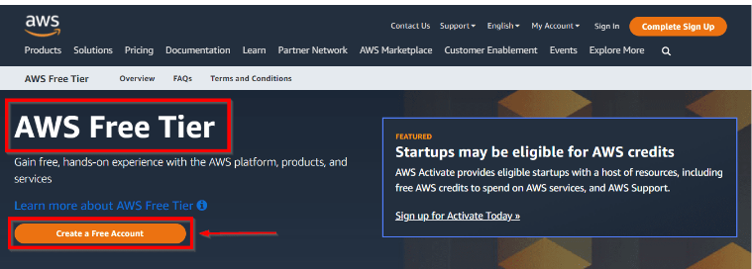**

**Step 3:**

Issue the details which you want to use to log in to your AWS account and click on Continue

**Email address:** Provide the mail id which hasn’t been registered yet with Amazon AWS.

**Password:** Type your password.

**Confirm password:** Authenticate the password.

**AWS Account name:** Choose a name for your account. You can change this name in your account settings after you sign up.

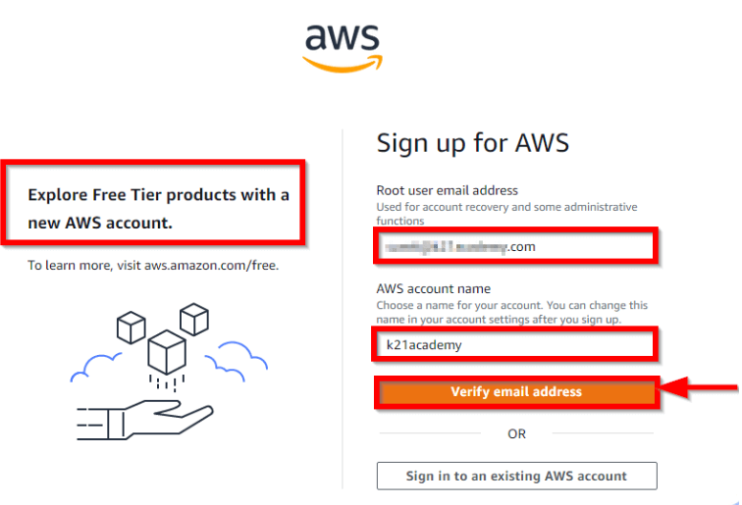

**Step 4:**

Select your AWS type (Professional/ Personal) Fill in the correct information to validate your account if you’re going to create personal use then click on “Personal Account” else use “Company Account”, Accepts the Terms and condition and then click on Create Account and Continue

**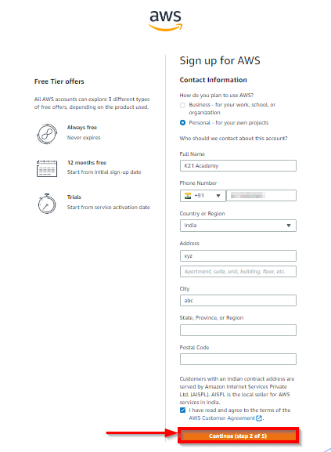**

**Note:** Make sure to provide proper contact details and mobile number to get the Verification code from AWS.

**Step 5:**

Payment and PAN information: In this step, you must fill in your credit card /Debit Card info and billing address and click on Secure Submit.

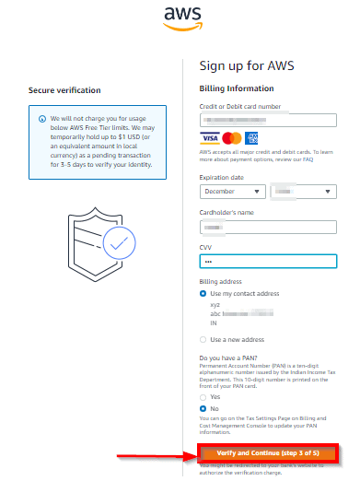

**Step 6:**

In this step, it will take you to the payment gateway to validate your payment information and for your credit card verification, Amazon will charge the minimum price based on Country. Here I have provided India, so Amazon charged 2 INR.

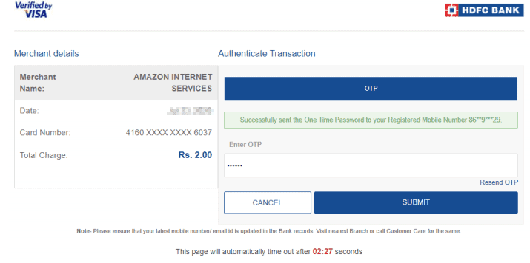

**Step 7:**

Phone verification: Here you will be taken to an identity verification page that will already have your phone number, so you just have to select either “Text message or Voice call” Provide a valid phone number, Solve the captcha, and then click on Send SMS or Call Me Now(depending upon your selection).

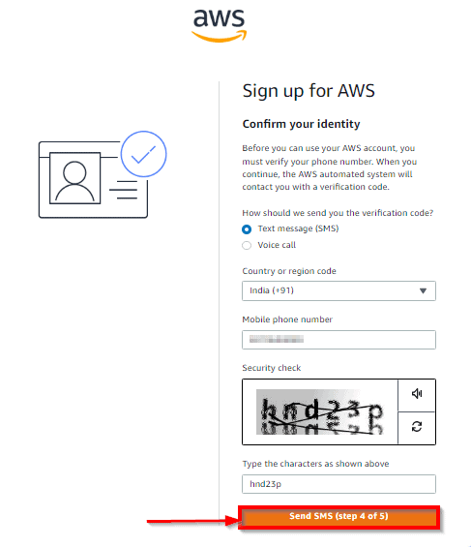

**Step 8:**

After clicking on Send SMS or Call me now, you will immediately receive a call or SMS from Amazon, for verification code, Enter your code then click on Verify Code.

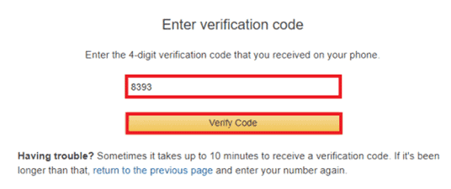

**Step 9:**

 Support plan: AWS support offers a selection of plans to meet your business needs.  
Select your suitable plan then click continues.

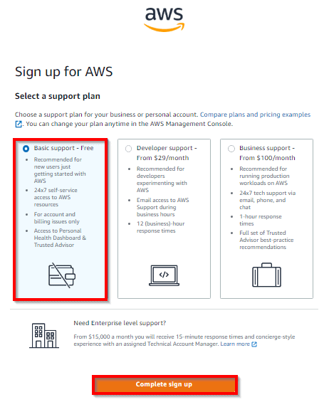

**Step 10:**

**Registration Confirmation page**

Once you completed all the above steps and processes. You’ll get the confirmation page as below. Now your account will be processed for activation. It may take somewhere between 30 minutes to 1 hour for you to receive an email confirmation that your Amazon Cloud Services account has been activated.

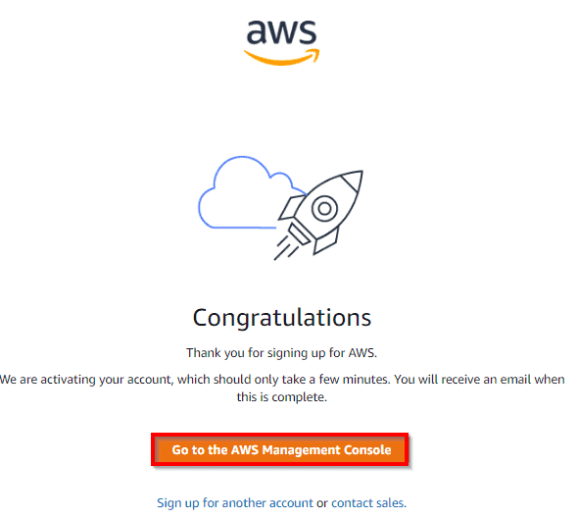

**Creating an EC2 instance of Linux OS:**

Sign in to the AWS Management Console.

* Click on the EC2 service.
* Click on the **Launch Instance** button to create a new instance.
  + Choose instant name
  + Now, we have different Amazon Machine Images. These are the snapshots of different virtual machines. Enter **Ubuntu** in search bar and hit enter then We will be using Ubuntu Server 22.04 LTS (HVM), SSD Volume Type
  + Choose an Instance Type, and then click on the Next. Suppose I choose a t2.micro as an instance type.(Free Tier Eligible)
  + Create a new key pair and enter the name of the key pair. Download the Key pair.
  + Select Key Pair type RSA and Private Key Format **.Pem**
  + Click on Launch Instance.
* Select created Instance and click on Connect after clicking connect to a instance page visible then click on EC2 instance tab and then click on connect.

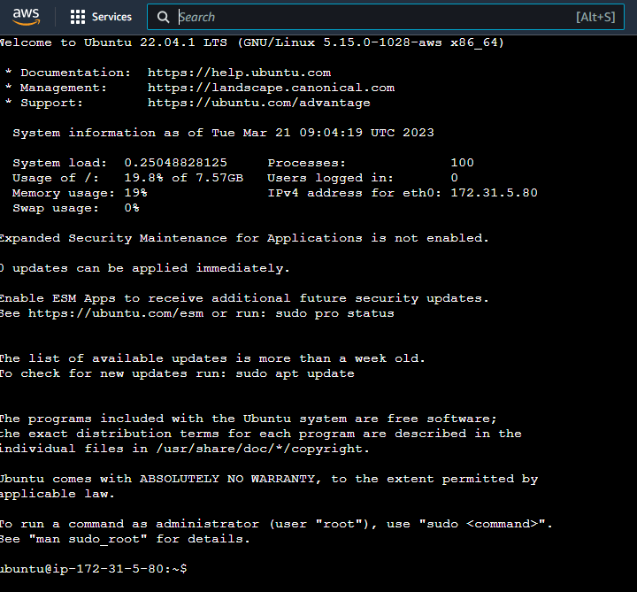

**free command:**

The free command gives information about used and unused memory usage and swap memory of a system. By default, it displays memory in **kb** (kilobytes). Memory mainly consists of RAM (random access memory) and swap memory. Swap memory is a part of hard disk drive that acts like a virtual RAM.

**Syntax:**

free -b     display information in Bytes

free -m     display information in Megabytes

free -g     display information in Gigabytes

**lscpu Command:**

Execute the “**lscpu**” command without invoking any argument in the terminal to display the complete picture of useful information about the processor

**ip address Command:**

ip command in Linux is present in the net-tools which is used for performing several network administration tasks. IP stands for Internet Protocol. This command is used to show or manipulate routing, devices, and tunnels. It is similar to [ifconfig](https://www.geeksforgeeks.org/ifconfig-command-in-linux-with-examples/" \t "_blank) command but it is much more powerful with more functions and facilities attached to it.

**Stop and Terminated an EC2 instance of Linux OS:**

* Select Instance from EC2 Dashboard
* Go to the Instances State tab
* Select Stop Instance
* After Instance services stop then Terminated the instance

**Conclusion:** Thus we have create an account (free tier account) on AWS and create and access EC2 instance (Linux OS Instance)